Inside IIS...
Right click the site where NAV current system is deployed.
Select <Add Application>.

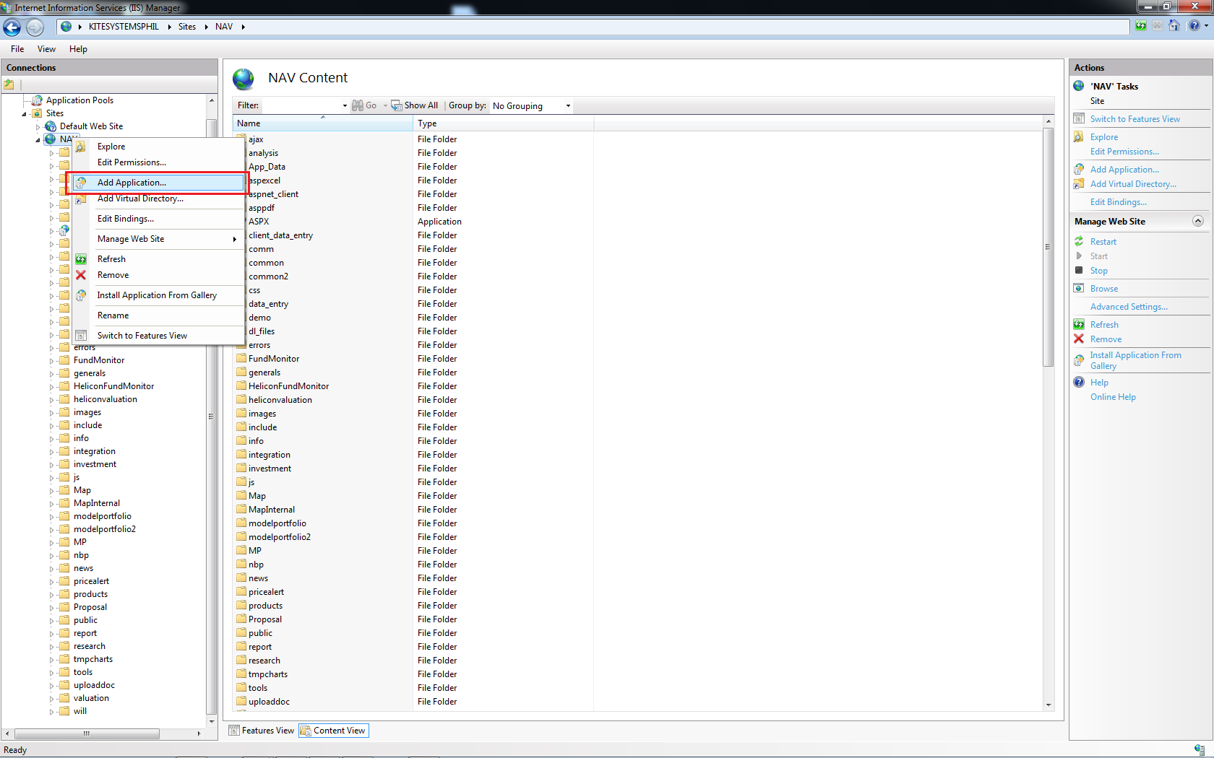

Type in “ASPX” on the <alias> field. 'note that no other value is accepted here'
For the <Physical path> field, type in or browse the path where you deployed the NAV Switch Application.

